

**Group Members:**

Aimen Wadood [P180002@nu.edu.pk](mailto:P180002@nu.edu.pk)

Muhammad Iftikhaar [P180054@nu.edu.pk](mailto:P180054@nu.edu.pk)

Umair Maratab[P180045@nu.edu.pk](mailto:P180045@nu.edu.pk)

Moin Khan[P180031@nu.edu.pk](mailto:P180031@nu.edu.pk)

**Group #7**

Table of Contents

**Introduction:** 3

**Marketing Plan:** 3

**Target Market:** 3

**Potential Market:** 3

**Product Strategies:** 4

**Pricing Strategies:** 4

**Promotion Strategies:** 4

**Distribution Channel:** 5

**Competitive Analysis:** 5

**Direct and Indirect Competitors:** 5

**Competitive Advantage:** 5

**Operational Plan:** 6

**Milestones:** 6

**Purchasing Procedures:** 6

# **Introduction:**

**Problem:**

Choosing a career is hard. Many children face this problem. They do not know what is best for them. If one cannot find your ideal career then your university life and professional life will be a burden on you. You would not take interest. One might be earning from the career that he does not like, but he/she would not be satisfied.

**Idea/Concept:**

*MapMyInterest* is here to help you choose a career that is made for you. It’s an app where you can find the best options for career of your interest and desire. All you have to do is to answer some questions and you will know the answer. This app is best for those people who are preparing for entrance test for universities. This app also tells you briefly about careers. So, if you are not sure that what exactly is in a specific field so can find it out just by downloading *MapMyInterest*. It will tell you the best career based on your talent and interest.

# **Marketing Plan:**

Market analysis has been done by survey through *Google Forms.*

## **Target Market:**

Students studying in;

* 9th, 10th, 1st Year and 2nd Year.
* A-levels, O-levels.

## **Potential Market:**

* About 56.74% of male students are at secondary level.
* About 43.25% of female students are at secondary level.
* About 55.55% of male students are at higher secondary level.
* About 44.44% of female students are at higher secondary level.

## **Product Strategies:**

This app will be made in order to help students to achieve their goals according to their interest. Students in high schools and colleges can take this test to find what is best career for them. The goal is to create awareness in students and parents that choosing right career is important in one’s life as it impacts student’s future. Choosing right career matters a lot, as one enjoys working and do not feel burden. Choosing wrong career can be a burden as people tend to get tired very easily and they try to get rid of work. The motive is to help students to find best careers for them so that they can have pleasure working in what they find interesting.

## **Pricing Strategies:**

Keeping in mind the responses to our survey, initially the company will charge 1k pkr.

## **Promotion Strategies:**

Based on the responses the company got from survey, the promotion will be done by;

1. Sessions in Schools/ Colleges.

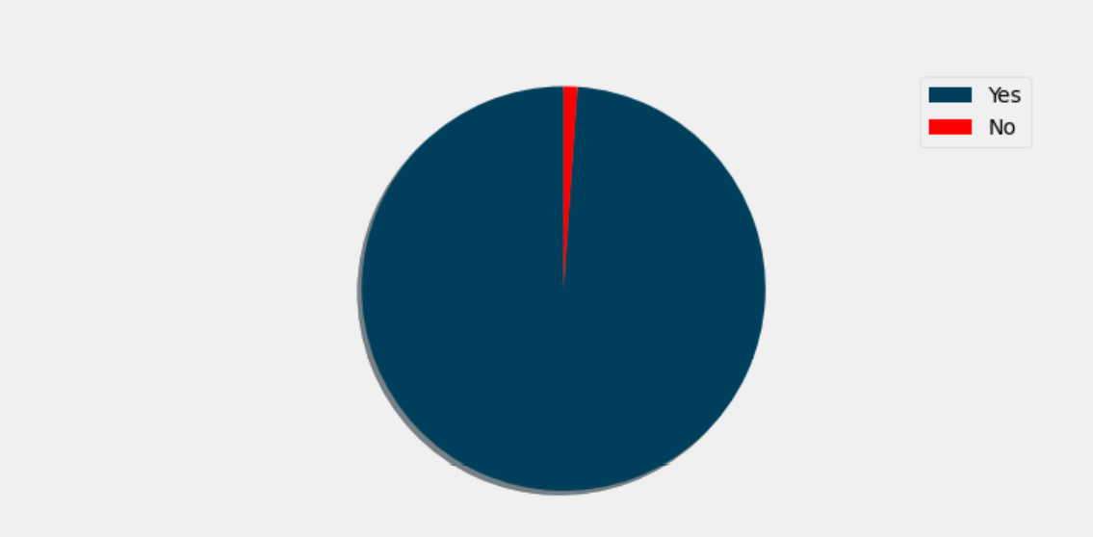

Figure 1: Live Sessions

1. Social Media.

## **Distribution Channel:**

The company will be using the following distribution channels:

1. Direct Distribution Channel.

It will be done by releasing the app online (Google Play).

1. In-direct Distribution Channel:

It will be done by giving the app to certain people and in turn they will send it forward to more people.

## **Competitive Analysis:**

## **Direct and Indirect Competitors:**

1. **Career Counselling Academy:**

They offer services for studying abroad consultancy in the region having experienced & foreign qualified staff.

1. **Siuk:**

They offer services for studying in abroad universities.

1. **Success Factor:**

It is education consultancy that provides its services physically.

1. **Eduvision:**

They are providing services of career counselling physically. They also provide past papers for different entrance tests.

1. **FES:**

FES study abroad consultants provide services for abroad education. They help students in visa application as well. They provide physical / telephonic counselling.

## **Competitive Advantage:**

MapMyInterest have the advantage that it will be offering services online and face to face. This app will not only focus on studying abroad but will also suggest best universities in Pakistan as well.

[Link to Google Form](https://docs.google.com/forms/d/1bnlnm7W1CNqLR_sLpMX33TWd-ZImC8vUeBu2nif9AP4/edit#responses)

# **Operational Plan:**

## **Milestones:**

1. **Designing Questions.**

Phycologist will design questions related to Human Physic. Technical Questions will be designed by company’s founders.

1. **Testing:**

After designing questions, testing will be done on dummy people in order to assure quality of questions.

1. **App Development.**

App will be developed by the collaboration of company founders. Later on, the app will be controlled and maintained by the company itself.

1. **Marketing.**

Marketing will be done by advertising the app. Advertisement will be done by different mediums, that is, through social media, banners, giving sessions in schools and colleges.

1. **Launch of app.**

After marketing, the app will be initially launched on *Google Play.* When the company will make some profit, then the app will be released on *App Store.*

## **Purchasing Procedures:**

The app will consist 2 levels. In level 1, the users will be asked to answer some questions and in turn they will get to know about their interests and fields that will best suit them.

In level 2, if the users want more counselling, then they will be asked to pay (transactions will be made online). After paying, they will be forwarded to a panel of speakers who will guide them in 1 or more interview sessions if needed.